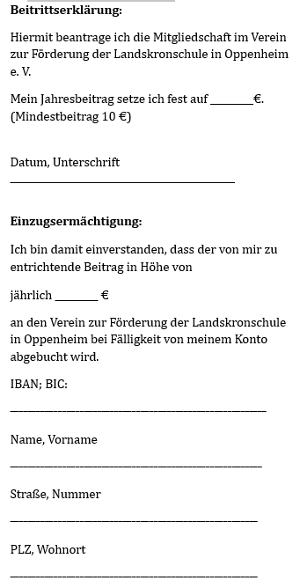
Datum, Unterschrift
------------------------------------------------------------------

